**Project Development - Delivery Of Sprint-3**

|  |  |
| --- | --- |
| **Date** | **18-11-2022** |
| **Team ID** | **PNT2022TMID19505** |
| **ProjectName** | **Project-IoT Based Safety Gadget For Child Safety Monitoring &**  **Notification** |
| **MaximumMarks** |  |

**IoT Device – Watson communication**

The data from IoT device should reach IBM Cloud

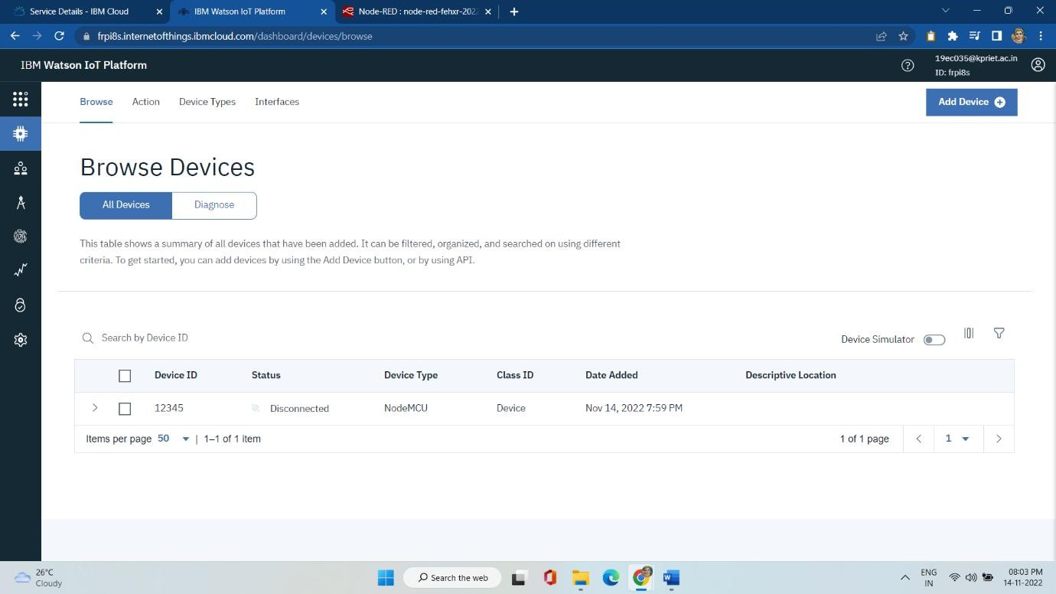

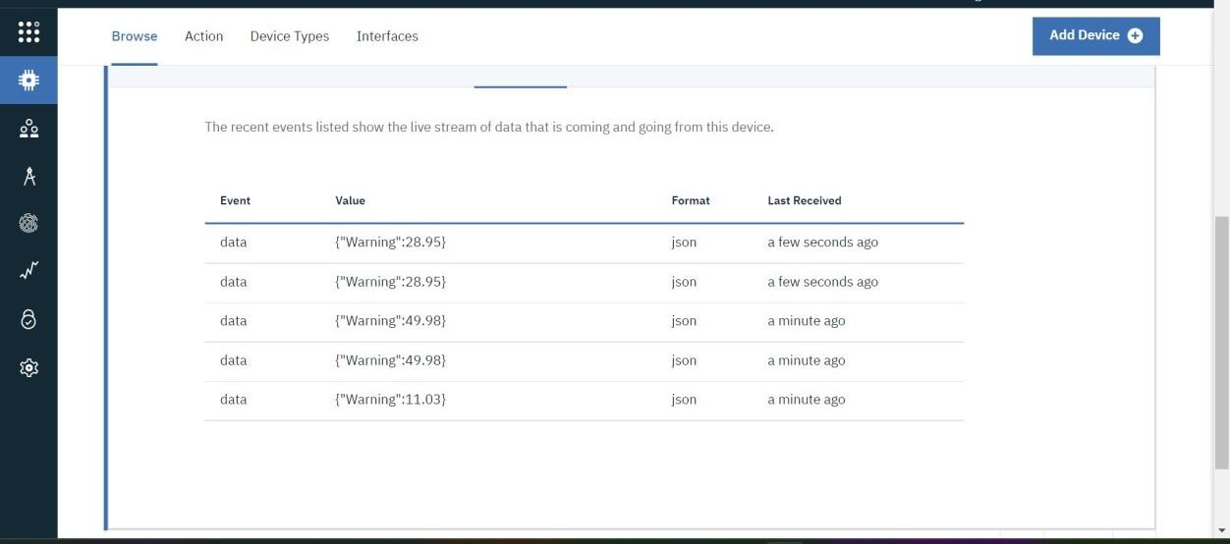

**NODE RED-CLOUDANTDB COMMUNICATION:**

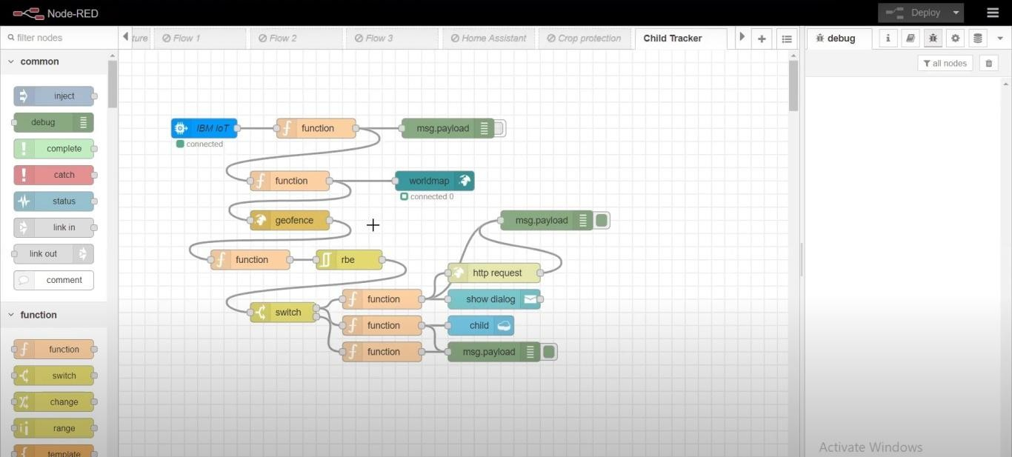

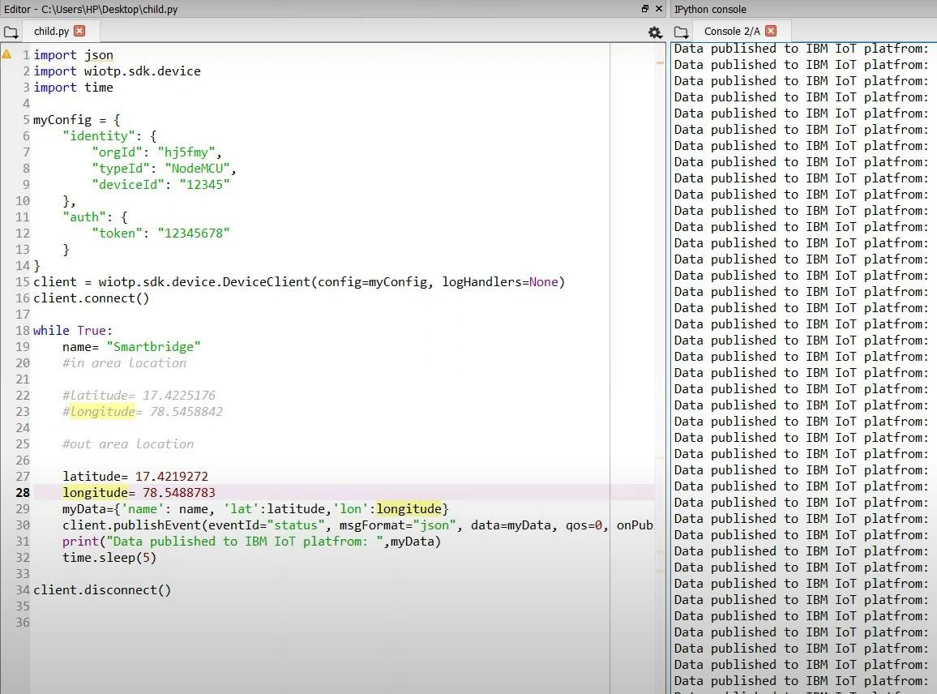

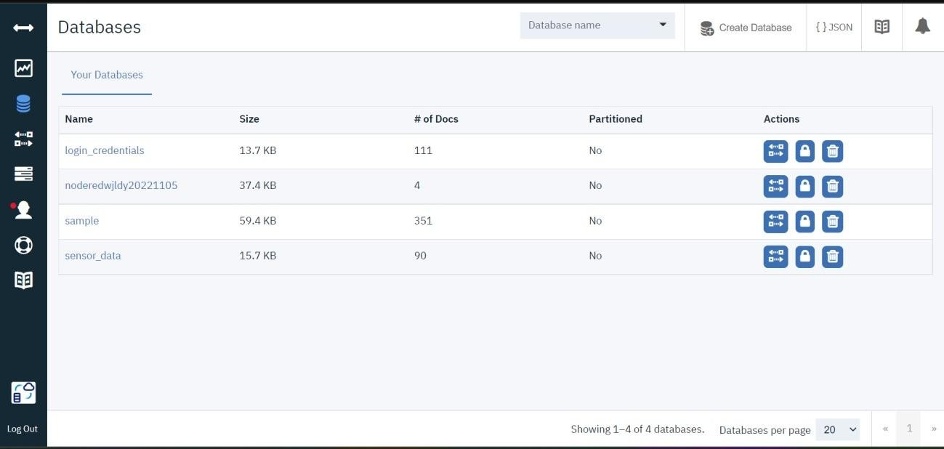

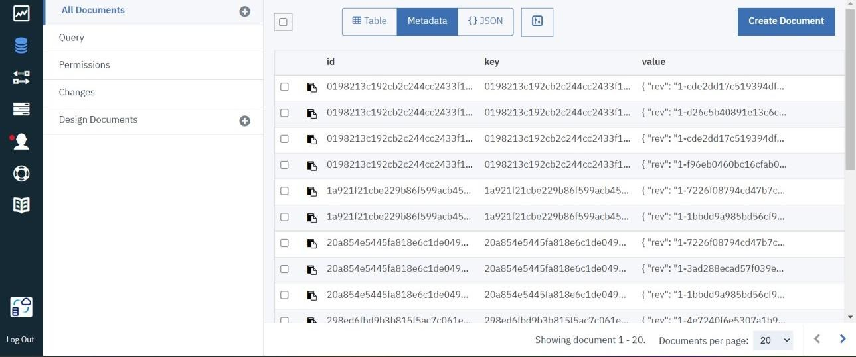

RESULT:The data stored in IBM Cloud should be properlyintegrated with Cloudant DB